SUPERVISOR PROMOTION AT POWER CEMENTS

Decision Scenario/ Background: 2-3 lines of decision scenario.

Hypothesis (if any)

Ha: Promotion decision is dependent on Training Attended Status

Data Description

A line about the dataset.

There are 300 datapoints collected with information such as Division, Training Attended and Promotion

<Descriptive Analysis>

| Frequencies of Training Attended | | | | | | | | | |
| --- | --- | --- | --- | --- | --- | --- | --- | --- | --- |
|  | | **Division** | | | | | | | |
| **Training Attended** | | **Production** | | **Purchase** | | **Quality** | | **Support** | |
| No |  | 67 |  | 24 |  | 31 |  | 38 |  |
| Yes |  | 57 |  | 25 |  | 33 |  | 25 |  |
|  | | | | | | | | | |

| Frequencies of Promoted | | | | | | | | | |
| --- | --- | --- | --- | --- | --- | --- | --- | --- | --- |
|  | | **Division** | | | | | | | |
| **Promoted** | | **Production** | | **Purchase** | | **Quality** | | **Support** | |
| No |  | 70 |  | 27 |  | 34 |  | 34 |  |
| Yes |  | 54 |  | 22 |  | 30 |  | 29 |  |
|  | | | | | | | | | |

 T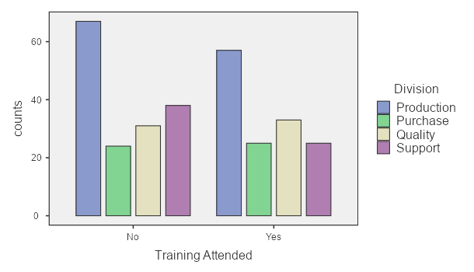

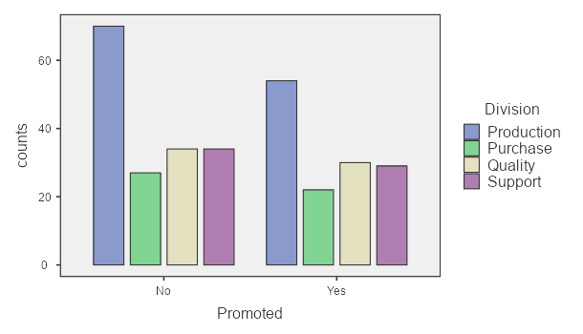

Figure 2. Number fo employees promoted per division since 2017

**Data Analysis**

To test the proposed hypothesis a Chi-square test of independence can be carries out

Contingency Table

| Frequencies of Training Attended | | | | | |
| --- | --- | --- | --- | --- | --- |
|  | | **Promoted** | | | |
| **Training Attended** | | **No** | | **Yes** | |
| No |  | 105 |  | 55 |  |
| Yes |  | 60 |  | 80 |  |
|  | | | | | |

Contingency Table

| Contingency Tables | | | | | | | | | |
| --- | --- | --- | --- | --- | --- | --- | --- | --- | --- |
|  | | | | **Promoted** | | | |  | |
| **Training Attended** | |  | | **No** | | **Yes** | | **Total** | |
| No |  | Observed |  | 105 |  | 55 |  | 160 |  |
|  | | Expected |  | 88.0 |  | 72.0 |  | 160 |  |
| Yes |  | Observed |  | 60 |  | 80 |  | 140 |  |
|  | | Expected |  | 77.0 |  | 63.0 |  | 140 |  |
| Total |  | Observed |  | 165 |  | 135 |  | 300 |  |
|  | | Expected |  | 165.0 |  | 135.0 |  | 300 |  |
|  | | | | | | | | | |

Based on the contingency table the Chi-square test result is as follows:

| χ² Tests | | | | | | | |
| --- | --- | --- | --- | --- | --- | --- | --- |
|  |  |  |  |  |  |  |  |
|  | | **Value** | | **df** | | **p** | |
| χ² |  | 15.6 |  | 1 |  | < .001 |  |
| N |  | 300 |  |  | |  | |
|  | | | | | | | |

**Result**

Considering alpha as 0.05 and p-value as <0.01

If p value is less than alpha, then reject Ho

Ho: The promotion and training attended are independent

Reject this

**Inference**

There is an association between Training Attended and Promotion decision

**Recommendation**

Yes, attending training increasing your chances of being promoted.